Winlink Presentation
@ HamCon: Zion 2024

Four Steps to setup winlink
- Install winlink
  - go to winlink download page; https://downloads.winlink.org/
  - read the page. There is much to explain
  - obtain winlink account email address -- youtube.com is your friend
  - fill out Setup Screen: call sign, password, locator number, name, address, etal.
- Install drivers for digirig or signalink . See Figure 1 & 2.
  - The device shows up with a yellow triangle. Meaning is does not have a driver.
  - After installing the driver, notice COM4 is identified as well as the PnP Sound Device.
- Set pointers to sound card & COM port
  - The sound card will pass audio between radio and computer
  - The PTT trigger also needs to be identified
  - They need to be set in the VARA FM settings window
  - See Figures 3 & 4
- Create and send email
  - Create email, Post to Outbox
  - Open session window (telnet, or VARA FM)
  - Select a gateway near you.
  - Press Start
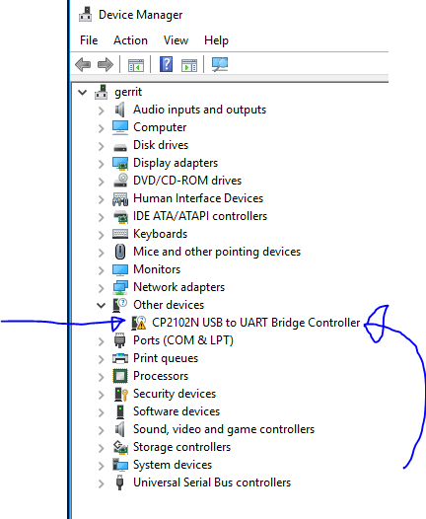Figure 1: Device Manager - shows device without driver
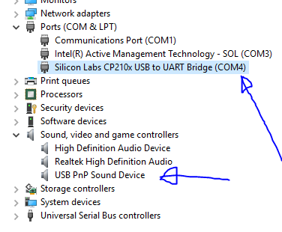Figure 2: Device Manager - after driver install, with 'USB PnP Sound Device"
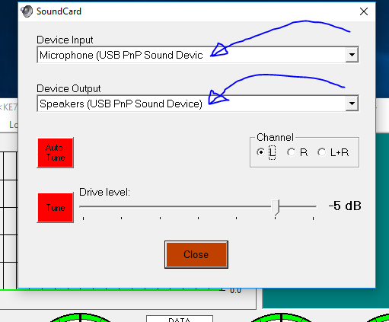Figure 3: Be sure to select the correct sound card device
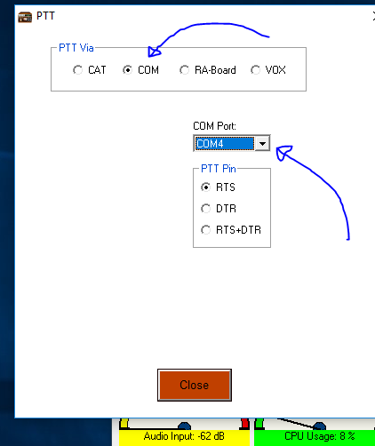Figure 4: Select the method for triggering the PTT

